English  Write a Clerihew Poem (see reverse). Remember you need 4 lines with 2 rhyming couplets. Try to make it funny! | Geography  Draw and label the four-figure grid references for each item on the map (see reverse). Remember to use the bottom left-hand corner of the square and go “along the corridor and up the stairs”. | RE  After the great flood God made a ‘covenant’ (promise) with Noah. Make a list of what humans should to do to look after each other, animals and the Earth.
French    Play Kim’s Game at home to practise pencil case items. (See reverse) | Art  Create a piece of art that copies the style of Wassily Kandinsky.   | Maths  Practice the column method for addition and subtraction. Practice borrowing and exchanging across a ten / hundred (I will be sending sheets home shortly).
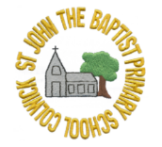
St. John the Baptist C of E Primary School Homework Menu
Term: Autumn 2 Class: 3 Theme: One Planet, Our World Hand-in day: Monday

